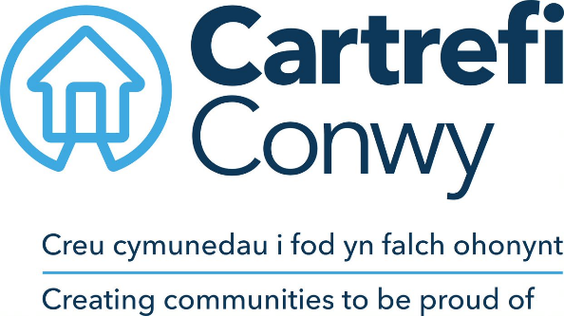
JOB DESCRIPTION

- JOB DETAILS
JOB TITLE | Customer Service Administrator
DIRECT REPORTS | None
TEAM | Customer Service Team
LOCATION | Hybrid: Morfa Gele and home working
SALARY DETAILS | Grade 3

- PURPOSE
To support the Customer Service Team with administration duties with a particular focus on keeping the company knowledge base accurate and up to date for colleagues and external customers.

- MAIN ACCOUNTABILITIES
- Maintain articles within the internal and external knowledge base. Review the usage statistics and provide regular reports for team managers to identify areas for improvements and updates.
- Maintain regular contact with relevant teams to confirm updates to policies and procedures that may require updates to the knowledge base.
- Support colleagues to use the remote mailing system: create user accounts and provide training
- Update the department’s internal sharepoint system
- Work with the ICT and department teams to update relevant letter templates on the Housing Management System
- General administration duties, including some minute taking, and cover of Reception duties as needed in the Receptionist’s absence.
Supporting annual projects for promoting customer experience such as National Customer Service Week and supporting the Customer Service Manager with the annual submission for the customer service excellence standard.

- CORPORATE ACCOUNTABILITIES
To actively support the overall delivery of Cartrefi Conwy’s objectives to provide an excellent, innovative and truly customer focused service.
To contribute to community involvement and tenant participation activities as required.
As a representative of Cartrefi Conwy, to, promote and maintain a positive attitude and image at all times.
To positively promote Cartrefi Conwy’s values; constructively challenging traditional ways of working, contrary behaviour or comments.
To ensure feedback is actively sought in order to inform service improvement for customers and develop more efficient and effective ways of working.
To ensure compliance with Cartrefi Conwy’s Standing Orders, policies and procedures, standards of probity relating to the organisation’s charitable status and Welsh Assembly Government Regulation.
To support the development, review and implementation of policies and procedures, in particular of:
- Health, safety and welfare initiatives
- The associations principles on Equality and Diversity
- Risk management initiatives
- Performance management practices
To utilise ICT technology and systems effectively by developing appropriate skills, adopting efficient business processes, and maintaining data securely and accurately.
To work collaboratively in cross functional working groups where required.

- WORK CONTEXT (environment, type of equipment)
The post is office based with ability for some home working. The regular use of ICT systems and technology is a requirement of the post.

- AUTONOMY AND DECISION-MAKING (limits and freedoms)
Work is typically self-paced (apart from reception duties which are customer driven) although tasks in this post are priority/deadline based. The post holder has the flexibility to decide what order tasks are done, however, all tasks will be expected to be completed to deadline or by priority set.
Examples of decisions that are referred are:
- Any items involving expenditure.
- Policy decisions.

Performance objectives are agreed with the Line Manager and performance is subject to review under the agreed PDR process.
- COMMUNICATIONS (the main communications that take place. frequency, purpose and method)
INTERNAL |  | Daily contact by telephone, face to face or e-mail with Cartrefi Conwy staff to seek advice and ascertain correct information for tenants or other customers/ visitors.
EXTERNAL |  | Daily communication with the general public and visitors to answer enquiries, forward callers and follow up on requests for advice and information about the services Cartrefi Conwy offer.
 | - AREAS OF COMPLEXITY (what provides most stretch)
 | Prioritising tasks and understanding requirements to follow procedures. Meeting the expectations of visitors, callers and staff may offer some complexity to the post as their aspirations are not always aligned with the resources and capabilities of Cartrefi Conwy in addition visitor and caller behaviour and needs may be unpredictable.

- AGREEMENT
Job Holders’ Signature: |  | Date:
Line Managers’ Signature: |  | Date:

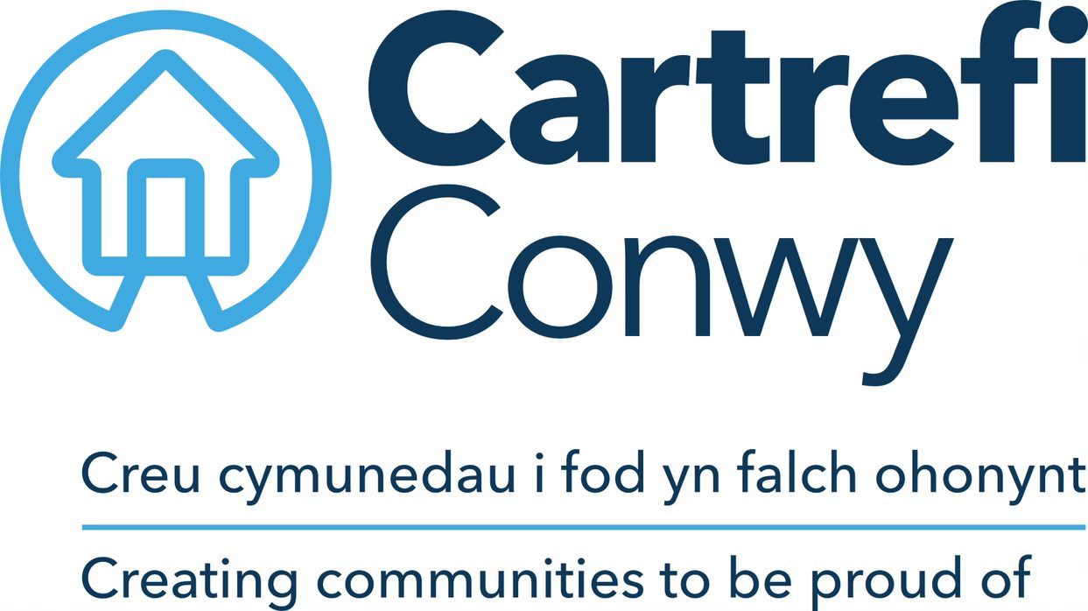 | PERSON SPECIFICATION  Customer Service Administrator

ACADEMIC / PROFESSIONAL QUALIFICATIONS | Essential / Desirable | How this will be assessed
GCSE passes at grade D or above in English and Maths (or equivalent) | Essential | Application / Certification
KNOWLEDGE & EXPERIENCE
An understanding of administrative duties | Essential | Application / Interview
An understanding of customer care | Essential | Application / Interview
Experience of administration duties | Desirable | Application / Interview
Experience of working to deadlines and delivering results | Desirable | Application/ Interview
SKILLS
Microsoft Office; Word (intermediate), Excel (Basic), Outlook (Basic) | Essential | Ability Test
Ability to maintain a flexible and professional approach to work | Essential | Application / Interview
IT literate with the ability to use computers and tablets confidently | Essential | Ability Test
Basic planning, prioritising and organising skills | Essential | Application / Interview
Accuracy and attention to detail in data entry | Essential | Ability Test
Ability to produce concise written communications | Essential | Ability Test
Willingness to learn and develop | Essential | Application / Interview
Welsh Language Skills | Highly Desirable | Application
CORE CARTREFI | Essential | Interview
Committed to Quality | Essential | Interview
Be innovative | Essential | Interview
Doing the Right Thing | Essential | Interview

Cartrefi Conwy are committed to Equality and Diversity in our activities

