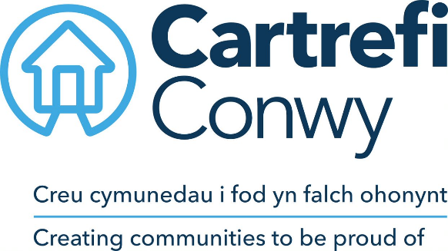
JOB DESCRIPTION

- JOB DETAILS
Job title | Development Programme Manager
Reports to | Assistant Director of Development and Growth
Direct reports | Development Project Managers, Assistant Development Surveyor and Quality Assurance Officer
Team | Development
Location | Hybrid working approach home / Morfa Gele HQ, Abergele
Salary details

- PURPOSE
To lead and manage the delivery of Cartrefi Conwy’s Development Programme.

To effectively contribute as part of the Management Team in developing the strategic direction for Cartrefi Conwy, working in partnership with the wider team.

To display leadership and direction to colleagues to ensure the business continues to develop high quality services to customers, contributing to the development of diverse, innovative and effective strategies, policies and procedures.

- DIMENSIONS Scale & Diversity
- Delivery of the organisations identified Development Programme
- Leadership of the Development Team responsible for delivering the development of homes in line with the organisations Development Strategy (circa 1000 homes over ten year programme)
- Assisting in the marketing and promoting of Group Strategies including but not limited to modular construction through Creating Enterprise Modular Solutions
- Support the Assistant Director of Development and Growth, support, development and empowerment of individuals to achieve aims and objectives
- Uphold and communicate the values and culture of Cartrefi Conwy

- MAIN ACCOUNTABILITIES
- To manage, lead, supervise and motivate the Development Team to ensure efficient operations in the delivery of allocated development programmes.
- Working closely with the Development Land Manager, research and investigate new initiatives and procurement methods from a delivery perspective for innovation in accordance with the Business Plan.
- Working closely with the Development Land Manager to apply a technical delivery perspective, assess potential new opportunities for development or redevelopment, liaising as appropriate with other departments, customers, consultants, external agencies, Local Authorities and Welsh Assembly Government.
- Work with the Development Land Manager in formulating new bids for growth and funding, organising the Development Team to develop the proposals and documentation required.
- Present and promote the highest possible image and capabilities of the Development Department in business circles, at functions, business events, network groups and high-level meetings.
- To produce projected expenditure plans, agree priorities, and establish budgets with the Assistant Director of Development and Growth for the function of the Development Team.
- Manage the Development Team, plan, co-ordinate and undertake all scheme work tasks to ensure compliance with approved procedures and policies and Welsh Assembly Government Requirements.
- To prepare draft scheme appraisal reports for the approval of new projects for submission to the Assistant Director of Development and Growth.
- To co-ordinate in conjunction with external consultants the procedures for tendering and selection of appropriate development contractors under traditional tender or framework methods of procurement and in accordance with standing orders.
- Manage the Development Team to ensure effective monitoring of projects to deliver the required technical standards from start to completion, ensuring that appointed consultants properly administer the contracts and that full financial and progress information is provided in a timely manner throughout the process.
- To liaise with the Finance section and the appointed solicitors to ensure that all-financial and legal requirements of developments are met.
- Work Closely with the Development Land Manager to create, organise and manage design, technical, legal teams, consultants and contractors to provide a comprehensive due diligence service and options for new development opportunities.
- Assist the Assistant Director of Development and Growth in developing policies and procedures to reduce and eliminate, where practical, exposure to risks.
- To provide technical support, advice and expertise on design issues to the Asset Management Team on adaptation (Physical Adaptation Works), refurbishment, improvements, repairs and maintenance work.
- To liaise, as appropriate, in the resolution of design and technical issues with external agencies – e.g. Welsh Assembly Government, Consultants, Contractors, Local Authorities, Supported Housing Agencies etc.
- To research, advise and maintain an up to date knowledge on design techniques, procurement, legislative and statutory issues affecting development, improvement, adaptation and maintenance work.

- CORPORATE ACCOUNTABILITIES
To actively support the overall delivery of Cartrefi Conwy’s objectives to provide an excellent, innovative and truly customer focused service.

To contribute to community involvement and tenant participation activities as required.

As a representative of Cartrefi Conwy, to, promote and maintain a positive attitude and image at all times.

To positively promote Cartrefi Conwy’s values, constructively challenging traditional ways of working, contrary behaviour or comments.

To ensure feedback is actively sought in order to inform service improvement for customers and develop more efficient and effective ways of working.

To ensure compliance with Cartrefi Conwy’s Standing Orders, policies and procedures, standards of probity relating to the organisation’s charitable status and Welsh Assembly Government Regulation.

To support the development, review and implementation of policies and procedures, in particular of:
- Health, safety and welfare initiatives
- The associations principles on Equality and Diversity
- Risk management initiatives
- Performance management practices

To utilise ICT technology and systems effectively by developing appropriate skills, adopting efficient business processes, and maintaining data securely and accurately.

To work collaboratively in cross functional working groups where required.

- WORK CONTEXT (environment, type of equipment)
The post will be a hybrid of home and office based with the requirement to travel locally. The regular use of ICT systems and technology is a requirement of the post. The post holder will be expected to work flexibly to ensure the Development needs of the business are met. This might mean working outside of normal office hours and at weekends when required and travelling to attend sites as required.

- AUTONOMY AND DECISION-MAKING (limits and freedoms)
- Work within defined frameworks, both internal and external, to work using own initiative to overcome and solve problems within existing broad procedure and policy direction.
- Recommend alternative resolutions to development and technical issues where established procedures are not available or unsuitable.
- Research, investigate, evaluate and implement new construction innovations, sustainability initiatives and alternative procurements methodology.

- COMMUNICATIONS (the main communications that take place. frequency, purpose and method)
INTERNAL |  | Colleagues and Managers across Cartrefi Conwy and Creating Enterprise on a daily basis to progress, manage and monitor development activity.
EXTERNAL |  | Contact by email and telephone plus regular attendance at site and other meetings with customers, contractors, consultants, external agencies, Local Authorities and Welsh Assembly  Various attendance at best practice, improvement and benchmarking groups
 | - AGREEMENT
 | Job Holders’ Signature: |  |  | Date:
 | Line Managers’ Signature: |  |  | Date:

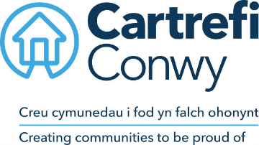 | Person Specification  Development Programme Manager

ACADEMIC / PROFESSIONAL QUALIFICATIONS | Essential / Desirable | How this will be assessed
Degree in a construction related subject with subsequent minimum 5 years relevant construction/project management experience | Essential | Application / Interview
Having or working towards a construction professional qualification i.e. RICS, CIOB, RIBA | Highly Desirable | Application
KNOWLEDGE & EXPERIENCE
Experience in delivering a development programme/projects | Essential | Application/ Interview
Possession of excellent numerical and analytical skills | Essential | Application / Interview
Experience of working with financial data and managing construction contracts | Essential | Application / Interview
Knowledge and understanding of business control processes | Essential | Application / Interview
Knowledge of application and interpretation of Welsh Assembly Government Development Quality Requirements and Welsh Housing Quality Standards | Highly Desirable | Application / Interview
Knowledge of building regulations and construction law and the ability to ensure that designs and work complies | Essential | Application / Interview
SKILLS
The ability to be proactive, innovative and think creatively | Essential | Application / Interview
The ability to evaluate and report on alternative procurement options | Essential | Application / Interview
The ability to analyse and evaluate local politics and their effects on potential development | Essential | Application / Interview
Ability to collate and effectively interpret management information and make reasoned recommendations to support business planning and service improvement | Essential | Application / Interview
Ability to present information in a way that is easy to understand and relevant to the audience through a variety of communication methods | Essential | Application / Interview
Well-developed interpersonal skills; Constructive challenge, Negotiating & Influencing | Essential | Application / Interview
Ability to work under pressure to tight timescales and be able to organise tasks effectively | Essential | Application / Interview
Ability to Drive* | Essential | Application / Certification
Welsh Language Skills | Desirable | Application / Interview
CORE CARTREFI
 | Essential | Interview
  Committed to quality
  Innovative
  Doing the right thing

Cartrefi Conwy are committed to Equality and Diversity in our activities

* Where disability precludes, this will be reviewed with candidates at interview stage to ascertain if there are any reasonable adjustments that can be made to this requirement.

