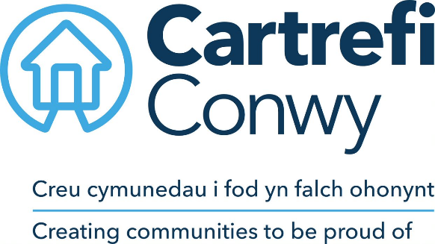
JOB DESCRIPTION

- JOB DETAILS
Job title | Development Project Manager
Reports to | Development Programme Manager
Direct reports | None
Team | Development
Location | Hybrid working approach home / Morfa Gele HQ, Abergele
Salary details | Up to £

- JOB PURPOSE ‘The Challenge’
Cartrefi Conwy is the largest social landlord in the county of Conwy with over 4000 homes across North Wales. Our social purpose is clear; to create communities to be proud of by putting our customers first and delivering value for all. We are an ambitious organisation looking for someone who can demonstrate a passion for delivering good quality development schemes in either the private or affordable housing sectors.
- RESPONSIBILITIES ‘What you will do’
- Assist Cartrefi Conwy in the development and implementation of the Development Strategy Identifying new development opportunities, undertaking feasibility studies and supporting the Development Team with relationship management of key partners and stakeholders, for example leading meetings, developing presentations, writing reports.
- Assist in the delivery of the Active Asset Management Policy, for example by assisting in feasibility studies and liaising with relevant stakeholders.
- Be responsible for the progression, monitoring and audit of schemes from inception to completion including liaison with property/land owners, external consultants/design team, relevant local authority officers and developers/contractors. For example monitor the development scheme cost against the agreed budget appraisal, provide Welsh Government returns, preparing and submitting grant applications and claims etc.
- Carry out post completion analysis of development costs to confirm compliance within original appraisal parameters and inform budget costs for future schemes.
- Collate and communicate information about activities, actions or issues within the communities in which Cartrefi Conwy operates to inform the actions of other teams.
- Contribute towards scheme design and development procedures. Review scheme proposals for compliance with Cartrefi Conwy ‘employer’s requirements’ and Welsh Government Development Quality Requirements.
- Contribute to the management of risk and take appropriate action to reduce risk in accordance with the Cartrefi Conwy’s Risk Matrix.
- Maintain an awareness and understanding of the development process and associated areas – including but not limited to the town and country planning process, market trends, construction methods and associated legislation, KPI’s and Energy/Sustainability standards etc
Ensure that the association’s equal opportunities policy, health and safety policy and customer service policies are complied with through all development activities and that all work is undertaken in accordance with relevant codes of practice and legislation.
- WORK CONTEXT (environment, type of equipment)
To work with a degree of flexibility to ensure the Development needs of the business are met. This might mean working outside of normal office hours and at weekends when required and travelling to attend sites as required.

- AGREEMENT
Job Holders’ Signature: |  | Date:
Line Managers’ Signature: |  | Date:

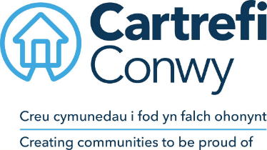 | Person Specification  Development Project Manager

ACADEMIC / PROFESSIONAL QUALIFICATIONS | Essential / Desirable | How this will be assessed
Degree in a Property related subject | Essential | Application
Relevant professional qualification or working towards eg. RICS | Highly Desirable | Application
KNOWLEDGE & EXPERIENCE
Ability to maintain appropriate Continuing Professional Development (CPD) | Essential | Application
Knowledge and understanding of construction theory and practice including Health and Safety | Essential | Application / Interview
Knowledge and understanding of construction related environmental and sustainability issues | Essential | Application / Interview
Experience in delivering development projects | Essential | Application/ Interview
Knowledge and understanding of Planning Policy & Principles | Essential | Application / Interview
Knowledge and understanding of Valuation Principles | Essential | Application / Interview
Working knowledge of relevant legislations (e.g. Building Regs, H&S, S106) | Essential | Application/ Interview
Working knowledge of Welsh Government affordable housing requirements (e.g. WDQR, WHQS and SHG procedures) | Desirable | Application/ Interview
Knowledge and understanding of appropriate scheme appraisal software | Highly Desirable | Application/ Interview
Knowledge and understanding of procurement principles | Essential | Application/ Interview
Knowledge and understanding of inspection criteria and building pathology | Essential | Application / Interview
SKILLS
Ability to communicate effectively with individuals at all levels | Essential | Application / Interview
Experience of report writing and delivering presentations to senior level managers | Essential | Application / Interview
Ability to work on own initiative and as part of a team | Essential | Application / Interview
Microsoft Office; Word, Excel, Outlook, Basic user level  (Excel Intermediate user level) | Essential  (Desirable) | Ability Test
Ability to Drive* | Essential | Application / Certification
Strong Interpersonal skills; Negotiation and Influencing | Essential | Application / Interview
Welsh Language Skills | Desirable | Application / Interview
CARTREFI COMPETENCIES
Committed to quality | Essential | Interview
Innovative | Essential | Interview
Doing the right thing | Essential | Interview

Cartrefi Conwy are committed to Equality and Diversity in our activities

* Where disability precludes, this will be reviewed with candidates at interview stage to ascertain if there are any reasonable adjustments that can be made to this requirement.

