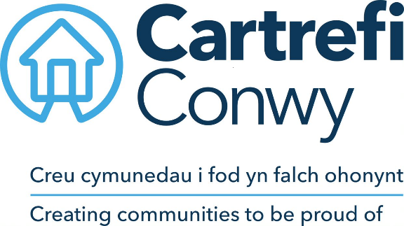
Governance Officer
ROLE PROFILE
Reports to: Company Secretary  Team: Governance | Line manages: N/A  Salary: Grade 7
JOB PURPOSE
We are looking for a motivated and enthusiastic Governance Officer at Cartrefi Conwy, whose main role is to support meetings at Board and senior leadership level, to work closely with our Executive Leadership Team and senior managers to offer guidance on governance-related matters, to help ensure compliance with regulatory matters, and to assist the Company Secretary to fulfil their statutory duties.
ROLE DIMENSIONS
You will have exceptional organisational skills, great attention to detail and will be an experienced meeting administrator with a track record of supporting meetings at Board level.
As a key team player, you will work collaboratively with those at the highest level of leadership (Board members, Executives, Assistant Directors & Company Secretary) and regularly engage with other internal and external stakeholders and colleagues.
Standards of Conduct & Confidentiality: Due to the nature of the work, you will have experience in handling confidential information.
Meeting-related activities: Meetings are held ‘in person’ or ‘virtually’, dependent on the preference of the Board. Meeting attendance and other arrangements may change at short notice, requiring re-prioritisation of work for self and others.

The postholder will be goal-driven and proactive, and will be confident to:
- Cc-ordinate and support Board/ Committee meetings.
- Co-ordinate and support internal meetings and workshops.
- Work flexibly / effectively engage with other members of the team to provide cover to ensure all meetings are managed efficiently if the usual lead contact is unavailable (for example due to sickness, holiday or other competing priorities).
- Advise colleagues generally on matters relating to Governance processes and procedures.
Statutory & Regulatory Compliance: We operate in a highly regulated sector, the purpose of this role is to assist the Company Secretary to prepare information for submission to the Regulator/ Companies House and to ensure that our internal Statutory Registers are kept up to date.
Working with and leading others: The postholder will take charge and confidently:
- Advise Board & Committee members on matters relating to their roles & responsibilities;
- Support members of the Executive Leadership Team in the planning meetings and related activities;
KEY RELATIONSHIPS
External:  Occasional contact with external stakeholders in respect of governance and community involvement activities. | Internal:  Board & Committee members, ELT and Asst.Dirs, Executive PA and People Managers (on a daily basis).
FOCUS & KEY RESPONSIBILITIES
We are looking for someone who is proactive and possesses high attention to detail. As an experienced meeting administrator, this role has exposure to a wide range of areas across the Business.
The Key Responsibilities for the role are:
- Meeting and Administrative Support
Support the Board and internal senior leadership colleagues by supporting the efficient preparation and conduct of meetings. Activities include:
- Agenda planning
- Preparing and circulating meeting packs electronically via Board Software
- Reviewing reports received for accuracy and to ensure formatting is correct;
- Attending/ arranging meetings
- Minute-taking/ recording decisions/ drafting resolutions
- Co-ordinating external attendees and presentations
- Reviewing meeting packs, collecting notes added to papers and gathering responses
- Following up on actions
- Reviewing and updating minutes from draft stage through to final versions, obtaining relevant approval as required
- Reviewing procedural matters relating to decision making (checking the Standing Orders, Terms of Reference and other policies/ procedures as relevant to ensure compliance)
You will be proficient in working with technology – particularly Microsoft Outlook and Microsoft Teams and will be capable of understanding ourinternal Board Software ‘Convene’ which is used regularly.
- Record Keeping
Maintain accurate records relating to Board & Committee meetings, individual board and committee members and other activities as relevant.

Ensure timely and on-going maintenance of company statutory records and support the Company Secretary to submit statutory and regulatory returns to Companies House.
- Knowledge
Be able to respond to enquiries about our Boards and Committees.

Support and where relevant lead on the co-ordination of responses to enquiries and requests for assistance from Board members and colleagues.

Escalate concerns or urgent issues to the Company Secretary or appropriate Executive in a timely and appropriate manner.

Work with our Business Continuity Specialists to lead on the preparation and coordination of Business Continuity plans. Ensure these plans are kept up to date and are appropriately tested.
- Providing Cover/ additional resource:
You will be flexible and willing to lend a hand to team members. Duties in this regard include acting as an additional resource in the absence or unavailability of other members of the Governance teams such as the Company Secretary, the Executive’s Personal Assistant or the Governance Trainee.
- Other activities:
The Governance Team work in a fast-paced environment, so the role requires someone who is able to work with a degree of autonomy and actively contribute to the development of good governance within the organisation.

Cartrefi Conwy has a growing governance structure, so other duties include but are not limited to:
- Providing governance/ administrative support to joint ventures and subsidiary organisations as required;
- Managing signing/ sealing procedures for legal contracts and agreements;
- Assisting the Governance Team to produce a calendar of meetings on an annual basis;
- Supporting the recruitment, induction and development of Board members alongside the Company Secretary;
- Assisting in the preparation for off-site Board events such as Strategy Days.

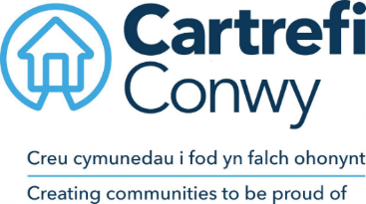
Person specification
QUALIFICATIONS
Essential  English GCSE grade C or above (or equivalent)  Desirable  ICSA/ICG qualification route,  Relevant qualification (or actively studying) for example; Law degree, | Assessed by:  Application (A) / Certificate (C)  A / C
EXPERIENCE
Essential | Assessed by:
- Experience of working effectively within guidelines/procedures while keeping information confidential | A / Interview (I)  I
- Experience of working effectively to deadlines and taking ownership of a busy workload | I
- Experience of providing proactive administrative support to management and co-ordinating follow-on actions | A/I
Desirable
- Previous experience of working within a Governance related role (highly desirable)  - Experience of working within a housing related field  - Experience of working in a legal practice, audit, compliance or regulatory function  - Experience of leading others (for example in relation to a team project or as a supervisor) | A/I  A/I  A/I

KNOWLEDGE AND SKILLS
Essential | Assessed by:
- Experience working with Microsoft products – including Outlook, Teams, Word, Excel, Powerpoint | Ability test (AT)
- Ability to work under own initiative to ensure deadlines are met and work is progressed  - Effective minute-taking skills  - Excellent organisational skills and attention to detail  - Well-developed communication, relationship management and customer service skills | A/I  AT  A/I  I
Desirable
- Knowledge of governance structures and legislation  - Knowledge of Governance software (Board portal) applications | I

