

JOB DESCRIPTION

- JOB DETAILS
JOB TITLE | ICT 1st Line Support Advisor
REPORTS TO | Business Systems Manager
DIRECT REPORTS | None
TEAM | ICT
LOCATION | Morfa Gele, Abergele & Home based
SALARY DETAILS | £18,690 to £19,587 (Grade 3 Point J – L)

 | - PURPOSE
 | To provide an initial point of contact for internal customers, to support and advise at the appropriate level; triaging calls to the next level where required. Providing technical ICT support to internal and external customers, assisting with hardware and software problems via phone, email, remote or onsite.
 | - DIMENSIONS - Scale & Diversity
 | To provide helpdesk triage for Circa 250 Employees based in 3 main office locations, with approximately 18 satellite sites. Allocating to the appropriate level as and when required.
- MAIN ACCOUNTABILITIES
1st Line Expectations
- Providing professional and efficient 1st line advice and support to all internal customers.
- To provide customers with a quality support service by speedy diagnosis of basic IT problems and taking prompt corrective action to resolve or escalate where appropriate. This support encompasses both core systems (i.e. MS Office products, MS Operating Systems etc) and 3rd party technical software.
- Great communication skills with all Cartrefi Conwy group staff and clients.
- To work as part of the ICT team to provide a single point of contact for ICT support for Cartrefi Conwy group and clients.
- To support with the building, maintaining and configuration of a variety of hardware and operating systems, including Laptops, thin clients and mobile devices.
- Provide support and assist with colleagues knowledge within the group and other customers in the development and use of software and systems, monitored by the Service Desk.
- Triage user requests which are wide ranging and require judgement to decide on the best course of action. These may involve computer, network, software applications, data errors etc.
- Strive to exceed in the delivery of operational KPI’s and customer SLA’s.
- Keep up to date with new developments in ICT and their best use application within the Cartrefi Conwy group.
- Assist on Project work as and when required.
- CORPORATE ACCOUNTABILITIES
To actively support the overall delivery of Cartrefi Conwy’s objectives to provide an excellent, innovative and truly customer focused service.

To contribute to community involvement and tenant participation activities as required.

As a representative of Cartrefi Conwy, promote and maintain a positive attitude and image at all times.

To positively promote Cartrefi Conwy’s values; constructively challenging traditional ways of working, contrary behaviour or comments.

To ensure feedback is actively sought in order to inform service improvement for customers and develop more efficient and effective ways of working.

To ensure compliance with Cartrefi Conwy’s Standing Orders, policies and procedures, standards of probity relating to the organisation’s charitable status and Welsh Assembly Government Regulation.

To support the development, review and implementation of policies and procedures, in particular:
- Health, safety and welfare initiatives
- The associations principles on Equality and Diversity
- Risk management initiatives
- Performance management practices

To utilise ICT technology and systems effectively by developing appropriate skills, adopting efficient business processes, and maintaining data securely and accurately.

To work collaboratively in cross functional working groups where required.

- WORK CONTEXT (environment, type of equipment)
The post will be a mixture of both office based and home working where appropriate. There may be some requirement to travel locally. The daily use of ICT systems and technology is an essential requirement of the post.
- AUTONOMY AND DECISION-MAKING (limits and freedoms)
The post is expected to operate within agreed policies and procedures. Work is typically customer driven and reactive with the need to balance priorities against planned projects and work. The post holder is required to prioritise all tasks within agreed deadlines, categories or by priority set.

Examples of the decisions the post can take are:
- Providing initial helpdesk advice or signposting colleagues and Managers to relevant policies and procedures

Examples of decisions that are referred are:
- Any items involving expenditure
- Exception to Policy decisions

- COMMUNICATIONS (the main communications that take place. frequency, purpose and method)
INTERNAL |  | Colleagues and Managers daily to provide basic helpdesk advice and troubleshooting. Signpost staff to relevant procedures, forms or information.
EXTERNAL |  | Local Authorities and Housing Associations, IT service providers, consultants & training providers.

- AREAS OF COMPLEXITY (what provides most stretch)
Prioritising customer driven workload and managing customer’s expectations may provide some complexity within the role.
- AGREEMENT
Job Holders’ Signature: |  | Date:
Line Managers’ Signature: |  | Date:

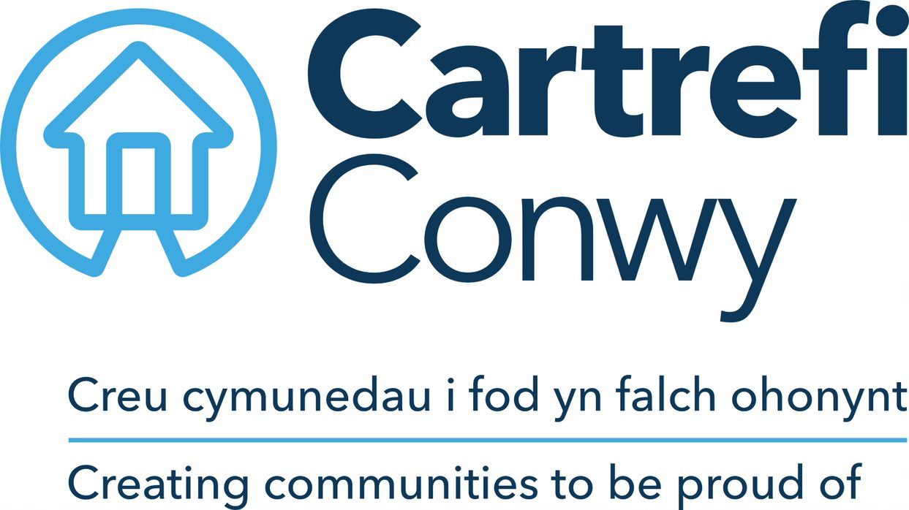 | Person Specification  ICT 1st Line Support Advisor

KNOWLEDGE & EXPERIENCE | Essential / Desirable | How this will be assessed
Knowledge of Microsoft applications, Server and desktop operating systems | Essential | Application / Interview
Working experience of Active Directory (AD) and user account management | Essential | Application / Interview
Working experience of hardware components – Mobile, Laptop & Desktop | Desirable | Application / Interview
Knowledge of Anti-virus & Web/Mail filtering principles | Desirable | Application / Interview
SKILLS & QUALIFICATIONS
Experience in ICT Support | Desirable | Application / Interview
Office / Office 365 user management and troubleshooting skills | Desirable | Application / Interview
Excellent communication skills both written and verbal and the ability to listen and interpret information | Essential | Application / Interview
Ability to plan and prioritise work within a reactive role | Essential | Application / Interview
IT certification or equivalent (i.e. ITIL/MCP, etc.) | Desirable | Application / Interview
Welsh Language Skills | Desirable | Application / Interview
Full UK Driving Licence | Desirable
CORE CARTREFI
Committed to quality | Essential | Interview
Innovative | Essential | Interview
Doing the right thing | Essential | Interview

