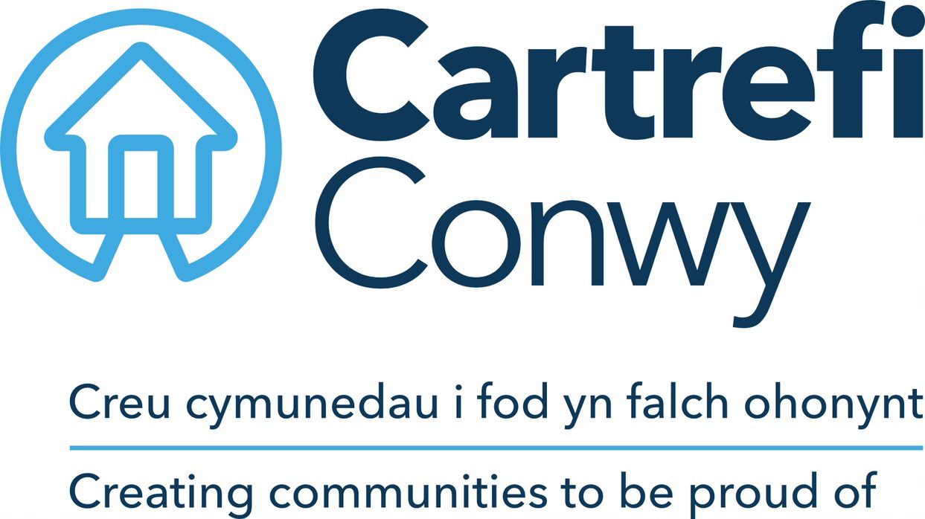
JOB DESCRIPTION

- JOB DETAILS
JOB TITLE | Independent Living Coordinator
REPORTS TO | Independent Living Manager
DIRECT REPORTS | None
TEAM | Independent Living Service, Neighbourhood Services
LOCATION | Cartrefi Conwy operational area (mobile as required to deliver services)
SALARY DETAILS | Up to £17,942 per annum

- PURPOSE
To provide advice, guidance and support to vulnerable tenants in order to help them to lead an independent life through a discreet and unobtrusive approach, encouraging continued mental and physical good health, independence and to promote participation in social activities in support of community development.

N.B Job description currently under review
- DIMENSIONS Scale & Diversity
Support provided in sheltered accommodation for elderly or vulnerable adults at a variety of locations.
60% of time dedicated to direct contact support of tenants (including paperwork) based on the three tier appointment structure:
20 minutes
40 minutes
60 minutes
40% of time based on scheme management (where applicable)

- MAIN ACCOUNTABILITIES
To maintain regular contact with tenants, providing day-to-day support identifying and following the agreed support plan for each individual and to monitor the health and general well-being of residents seeking support where necessary from relevant agencies.

To develop and maintain positive relationships with key contacts such as relatives, friends, social services, GPs and district nurses, etc as appropriate, in order to advocate support from relevant agencies when necessary for tenants including supporting multi-disciplinary case meetings.

In cases of emergency, for example if a tenant is unwell, shop and collect prescriptions on their behalf.

Maintain up to date support plans and monitoring of Support Outcomes to meet Supporting People requirements.

Maintain regular and up to date log of contact with clients and site incidents.

Organise social activities, encouraging and facilitating resident involvement in community activities – for example by arranging transport and supporting events etc.

Be responsible for welcoming new residents, ensuring they have a Support Plan and information about facilities within the scheme and the neighbourhood and undertaking tenant specific risk assessments and establishing personal emergency evacuation plans (PEEPs).

Report any issues to do with building or site defects and the Safety of tenants to the Neighbourhood Coordinator. Monitoring the upkeep of the site in general and the cleanliness and state of communal areas.

To perform relevant safety checks in order to maintain a safe environment for residents including legionella checks where applicable, on telecare or smart technology and for fire safety for example checking fire alarm system tests, access and egress, door override keys, fire doors and windows etc are in situ and working correctly both in individual properties and in communal areas maintaining records and seeking appropriate remedial actions where necessary.

Where applicable be responsible for monitoring the use of the Community Centre and reporting any misuse or damage to Customer Services.

The post holder will, from time to time, be required to undertake other duties of a similar nature as may reasonably be required by his/her line manager including relief cover of different areas.

- CORPORATE ACCOUNTABILITIES
To actively support the overall delivery of Cartrefi Conwy’s objectives to provide an excellent, innovative and truly customer focused service.

To contribute to community involvement and tenant participation activities as required.

As a representative of Cartrefi Conwy, to, promote and maintain a positive attitude and image at all times.

To positively promote Cartrefi Conwy’s values; constructively challenging traditional ways of working, contrary behaviour or comments.

To ensure feedback is actively sought in order to inform service improvement for customers and develop more efficient and effective ways of working.

To ensure compliance with Cartrefi Conwy’s Standing Orders, policies and procedures, standards of probity relating to the organisation’s charitable status and Welsh Assembly Government Regulation.

To support the development, review and implementation of policies and procedures, in particular of:
- Health, safety and welfare initiatives
- The associations principles on Equality and Diversity
- Risk management initiatives
- Performance management practices

To utilise ICT technology and systems effectively by developing appropriate skills, adopting efficient business processes, and maintaining data securely and accurately.

To work collaboratively in cross functional working groups where required.

- WORK CONTEXT
This role will be carried out in Cartrefi Conwy’s neighbourhoods, with some requirement to travel locally within the area within which Cartrefi Conwy operates. Some time each week will be spent within an office environment. The use of ICT systems and technology is a requirement of the post.

- AUTONOMY AND DECISION-MAKING
The post holder has some freedom to plan the order of activities within the day according to priorities.

The post holder is expected to comply with all policy and procedures and health and safety regulations and is expected to refer to the Independent Living Manager for advice and guidance on the consistent and safe application of these and will refer unresolved matters with tenants (such as tenancy breaches or repairs) to the Neighbourhood Coordinator.

- COMMUNICATIONS
INTERNAL | Weekly contact with the Senior Independent Living Coordinator to seek advice and guidance on activities.  Neighbourhood Teams (Conwy Housing Solutions, Homefinder etc to refer cases of Anti Social Behaviour.
EXTERNAL | Daily contact with tenants and residents on support plans and supporting the maintenance of tenancy conditions (face to face or via the telephone) and arranging social activities.  Regular contact with other organisations to encourage a collaborative approach to support for tenants (GP’s, District nurses, Activity providers etc)  Daily contact with Care Connect to pick up service messages.

- AREAS OF COMPLEXITY (what provides most stretch)
Meeting the expectations of tenants or residents may offer some complexity to the post as their aspirations are not always aligned with the resources and capabilities of Cartrefi Conwy.
Complex and changes needs of customers especially relating to health and social care needs that cannot always be met by other agencies in a timely manner can also present stretch in this role.

- AGREEMENT
Job Holders’ Signature: |  | Date:
Line Managers’ Signature: |  | Date:


Person Specification
INDEPENDENT LIVING COORDINATOR
The Independent Living Coordinator will be able to cultivate relationships, counsel, negotiate with and advise others, whilst being acommodating and unassumming. They will take a thorough, systematic and logical approach to situations as well as being persistent in order to achieve results. A confident communicator, they will be enthusiastic and approachable, easily creating and maintaining goodwill.
ACADEMIC /PROFESSIONAL QUALIFICATIONS | Essential / Desirable | How this will be assessed
Good level of Numeracy and Literacy | Essential | Application / Ability Test
NVQ (or equivalent) in care or support work or related Housing subject | Desirable | Application / Certification
KNOWLEDGE & EXPERIENCE
Experience of working with elderly or vulnerable people and arranging or facilitating social activities | Essential | Application / Interview
Experience of inter-agency working and knowledge of relevant services in order to advocate confidently on behalf of others | Essential | Application / Interview
Experience of establishing and reviewing support plans with tenants | Desirable | Interview
SKILLS
Initiative and ability to work independently making well-judged decisions | Essential | Application / Interview
Interpersonal skills, to deal sensitively, calmly and professionally with tenants or staff experiencing difficulties, in emergency situations or to advocate in interests of tenant | Essential | Interview
Ability to confidently use Microsoft Office; Word, Outlook (Basic user level) | Essential | Ability Test
Administrative skills to complete support plans and maintain tenant records accurately | Essential | In Tray Exercise
Ability to drive and the use of a car* | Desirable | Application/ Certification
Welsh Language Skills (level 3 and above) | Essential | Application / Interview
CORE CARTREFI
Committed to Quality | Essential | Interview
Innovative | Essential | Interview
Doing the Right Thing | Essential | Interview

Cartrefi Conwy are committed to Equality and Diversity in our activities

* Where disability precludes, this will be reviewed with candidates at interview stage to ascertain if there are any reasonable adjustments that can be made to this requirement.

