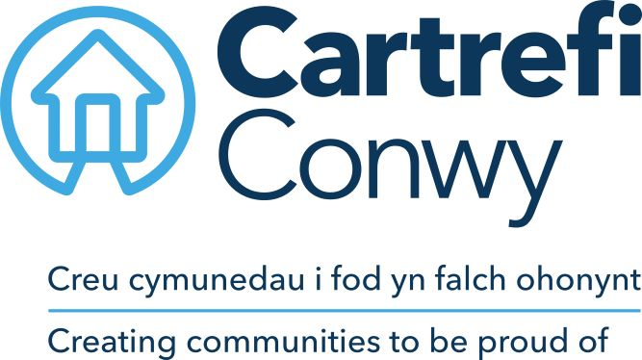
JOB DESCRIPTION

- JOB DETAILS
JOB TITLE | Marketing and Administration Officer
REPORTS TO | Independent Living Manager
DIRECT REPORTS | None
TEAM | Independent Me
LOCATION | Abergele (include agile)
SALARY DETAILS | TBC

- PURPOSE
To provide a comprehensive administrative and marketing support to a high-quality client focused service. To gather and input data for the performance of the service by phone or face to face contact with users. Provide a primary point of contact to clients and volunteers and assist in the development of the marketing strategy and promotion of the service in collaboration with the groups communication team.
- DIMENSIONS Scale & Diversity
Supports the marketing and administration of the service. Handle calls covering client’s requests, logging feedback and dealing with complaints and compliments.
Responsible for collating and accurately logging all information onto the database in accordance with GDPR.
- MAIN ACCOUNTABILITIES
- Promote the service through various forms of social media and work in collaboration with the group communications teams to include press releases.
- Contact partners and external organisations to promote the service.
- Administrate, record and monitor data of new/current clients of the service in accordance with GDPR.
- Assist the finance team in the administration of payments for the service.
- Monitor all enquiries in relation to the service.
- Assist in organising and implementation of customer events and exhibitions.
- Assist with the collation of information for promotional literature.
- Monitor the demographics of the service in line with new/current clients.
- Assist in the collation of evidence for the key performance indicators (KPI`S) of the service.
- Contact clients to gather and record feedback on the service.
- Assist with the handling and monitoring of complaints/compliments of the service.
- Provide regular updates to the group on how the service is progressing on Sharepoint.
- Any other duties as deemed necessary by management.

- CORPORATE ACCOUNTABILITIES
To actively support the overall delivery of Cartrefi Conwy’s objectives to provide an excellent, innovative and truly customer focused service.

To contribute to community events and client’s participation activities as required.

As a representative of Cartrefi Conwy, to promote and maintain a positive attitude and image at all times.

To positively promote Cartrefi Conwy’s values, constructively challenging traditional ways of working, contrary behaviour or comments.

To ensure feedback is actively sought to inform service improvement for customers and develop more efficient and effective ways of working.

To ensure compliance with Cartrefi Conwy’s Standing Orders, policies and procedures, standards of probity relating to the organisation’s charitable status and Welsh Assembly Government Regulation.

To support the development, review and implementation of policies and procedures, in particular of:
- Health and safety, and welfare initiatives
- The associations principles on Equality and Diversity
- Risk management initiatives
- Performance management practices

To utilise ICT technology and systems effectively by developing appropriate skills, adopting efficient business processes, and maintaining data securely and accurately.

To work collaboratively in cross functional working groups where required.

- WORK CONTEXT (environment, type of equipment)
The post is predominantly office based with the requirement to travel locally for meetings and promotional and partnership events. The regular use of ICT systems and technology is a requirement of the post.

- AUTONOMY AND DECISION-MAKING (limits and freedoms)
The post is expected to operate within agreed policies and procedures have a degree of autonomy to manage their own time, prioritise and plan the working week within the scope of the service whilst using their own initiative and values when supporting clients who are receiving support through the Independent Me service.
Examples of the decisions the post can take are:
- Providing or directing clients to the correct information.
- Arrange sign-up for the service.
- Book appointment with the client.
Examples of decisions that are referred are:
- Financial or contractual in relation to the service.
- Policy decisions.
The post holder has some freedom to plan the order of activities within the day according to priorities; however, an element of the role will require the post holder to meet deadlines in line with the service key performance indicators.

- COMMUNICATIONS (the main communications that take place. frequency, purpose and method)
INTERNAL | Regular contact by telephone, e-mail with colleagues, volunteers to deliver an excellent and agreed service
EXTERNAL | regular contact by telephone, face to face or email and the public on to answer enquiries and follow up on requests for advice and information about the service that Independent Me has to offer

- AREAS OF COMPLEXITY (what provides most stretch)
Meeting the expectations of clients to the service, ensuring targets are met in line with the business to ensure the outputs are me in line with the capabilities of the group.
Feedback from clients following the delivery of the service. High number of calls and the impact that can have.

- AGREEMENT
Job Holders’ Signature: |  | Date:
Line Managers’ Signature: |  | Date:

PERSON SPECIFICATION
MARKETING AND ADMINISTRATION OFFICER
The Marketing and Administration officer will be able to provide a comprehensive administrative and marketing support, gathering and inputting data for the performance of the service in the provision of a high quality client focused service.
ACADEMIC /PROFESSIONAL QUALIFICATIONS | Essential / Desirable | How this will be assessed
5 GCSE`s or equivalent | Essential | Application/Certification
KNOWLEDGE & EXPERIENCE
Experience of using digital communication channels, eg Facebook, Twitter, LinkedIn, Instagram | Essential | Application / Interview
Experience of working in an administrative or marketing role | Desirable | Application / Interview
To be flexible, adaptable and have a ‘can do’ attitude. Have strong organisational skills with the ability to work under pressure and to tight deadlines | Essential | Interview
Experience of maintaining/updating data | Essential | Application/Interview
Experience of following laid down procedures/processes, as well as willingness to suggest changes to improve systems | Essential | Application/Interview
Experience of maintaining/updating websites | Desirable | Interview
Knowledge of current marketing practices and how they should be applied | Desirable | Interview
Experience of preparing for, and attending organised events, e.g. conferences/exhibitions | Desirable | Application/Interview
SKILLS
Initiative and ability to work independently making well-judged decisions | Essential | Application / Interview
The ability to build and maintain relationships at all levels and be a team player | Essential | Interview
To use a creative and innovative approach and be proactive and dynamic at all times | Essential | Application/Interview
Ability to drive and the use of a car* | Desirable | Application/ Certification
Welsh Language Skills (level 2 and above) | Desirable | Application / Interview
CORE CARTREFI
Committed to Quality | Essential | Interview
Innovative | Essential | Interview
Doing the Right Thing | Essential | Interview

Cartrefi Conwy are committed to Equality and Diversity in our activities

* Where disability precludes, this will be reviewed with candidates at interview stage to ascertain if there are any reasonable adjustments that can be made to this requirement.

