
JOB DESCRIPTION

- JOB DETAILS
JOB TITLE | Money Support Advisor
REPORTS TO | Income Recovery Manager
DIRECT REPORTS | N/A
TEAM | Incomes Management Team
LOCATION | Morfa Gele, Abergele
SALARY DETAILS | (Grade 6)

- PURPOSE
To provide specialist welfare benefits and money support advice advice to tenants to ensure that those using the service have the opportunity of having their income fully maximised and expenditure reduced;
To ensure that tenants are claiming their full entitlement of all available benefits.
To offer basic money management and budgeting advice where needed.
To support the Associations Tackling Poverty agenda creating partnership opportunities where possible to give tenants access to wider external financial inclusion services
To liaise closely with colleagues to provide advice and support and to develop their understanding and knowledge of Welfare Benefits, including Universal Credit

- DIMENSIONS Scale & Diversity
The post deals with an on-going case load. Tenants range from young people, families, couples with no children, elderly and vulnerable. One third of Cartrefi Conwy’s stock is sheltered accommodation.

- MAIN ACCOUNTABILITIES
To prepare full financial assessments for tenants as appropriate and assist with benefit claims where appropriate;
To effectively manage a housing advice caseload. To ensure that all files, records and computer based data are maintained accurately at all times. To ensure a thorough and complete audit trail for the Income Management Team.
To provide expert advice, information and assistance on housing and related support issues including working closely with other agencies to ensure a co-ordinated and consistent approach.
To keep up to date with relevant legislation, case law, Government guidance/policy and best practice initiatives.
To respond to enquiries from other agencies and the public and facilitate/attend public meetings in relation to the post holder’s responsibilities. To prepare reports and liaise with Members on enquiries relating to welfare rights.
Identify the need for and initiate take up campaigns regarding for example the introduction of a new benefit, or highlighting existing benefits;
Liaise with other agencies on benefit enquiries and issues on individual and general matters, negotiating and mediating with other agencies in individual cases and on appeals (representing tenants at appeals where necessary);
Update staff with regards to changes in welfare rights legislation as it affects the Association and liaise with the Income Manager and HR to develop and, where feasible, deliver training to allow colleagues to deal with frequently asked questions and general enquiries;
Respond effectively and efficiently to tenants requests for assistance with Housing Benefit/Universal Credit housing costs as they affect the Association including:
- Calculating benefit at tenant sign up date
- Expediting the processing of new claims
- Making backdated claims
- Dealing with overpayments
- Dealing with correspondence regarding change of circumstances
- Dealing with annual revisions, stops and changes in Housing Benefit/Universal Credit housing costs payments
Follow through rent increases to ensure that Housing Benefit or Universal Credit implement benefit increases in a timely and accurate manner;
Liaise with the Universal Credit Advisor in order to ensure that tenants are fully supported to make and maintain a claim for Universal Credit
Keep abreast of changes in Welfare Reform legislation resultant practice and report on the impact of same on the Association;
Attend Welfare Rights Forums and any other relevant work groups as agreed by the Income Manager;
Offer Welfare Benefits Advice to projects accommodated by the Association e.g. Supporting People, with the agreement of the Income Manager;
Contribute to the development and improvement of a Welfare Benefits service by establishing best practice and assisting in the development of appropriate policy and process;
Report regularly on progress including case load, outcome and impact on technical and non-technical arrears;
Such other duties as may reasonably be requested by the Income Manager such as attending evening Committee Meetings etc.

- CORPORATE ACCOUNTABILITIES
To actively support the overall delivery of Cartrefi Conwy’s objectives to provide an excellent, innovative and truly customer focused service.
To contribute to community involvement and tenant participation activities as required.
As a representative of Cartrefi Conwy, to, promote and maintain a positive attitude and image at all times.
To positively promote Cartrefi Conwy’s values; constructively challenging traditional ways of working, contrary behaviour or comments.
To ensure feedback is actively sought in order to inform service improvement for customers and develop more efficient and effective ways of working.
To ensure compliance with Cartrefi Conwy’s Standing Orders, policies and procedures, standards of probity relating to the organisation’s charitable status and Welsh Assembly Government Regulation.
To support the development, review and implementation of policies and procedures, in particular of:
- Health, safety and welfare initiatives
- The associations principles on Equality and Diversity
- Risk management initiatives
- Performance management practices
To utilise ICT technology and systems effectively by developing appropriate skills, adopting efficient business processes, and maintaining data securely and accurately.
To work collaboratively in cross functional working groups where required.

- WORK CONTEXT (environment, type of equipment)
The post is office based with regular and frequent requirement to travel locally to meet tenants. The post holder is also required to attend and support tenant events. A number of these events may take place outside normal working hours. The regular use of ICT systems and technology is a requirement of the post.

- AUTONOMY AND DECISION-MAKING (limits and freedoms)
The post is expected to operate autonomously within agreed policies and procedures and has considerable freedom to deal with all operational matters that relate to financial inclusion.

Examples of the decisions the post can take are:
- Developing and running activities within approved budgets.
- Convene meetings with tenants or partner agencies.

Examples of decisions that are referred are:
- Any items involving expenditure.
- Approval for new initiatives.
Performance objectives are agreed with the Incomes Team Manager and performance is subject to review under the agreed PDR process.

- COMMUNICATIONS (the main communications that take place. frequency, purpose and method)
INTERNAL | Neighbourhood Services and Community Involvement and Creating Futures Teams to provide advice and work on initiatives to improve financial inclusion for tenants.
EXTERNAL | Tenants and any supporting networks, such as Social Services, voluntary and charitable agencies such as Citizens Advice Shelter will be on a weekly basis  Local Authority, i.e. Welfare Rights and Housing Benefit will be on a weekly basis

- AREAS OF COMPLEXITY (what provides most stretch)
Involving tenants in developing innovative and clear ways which will encourage tenants to engage may create complexities, as may the positive adoption of new and innovative ideas, where tenant knowledge is not always aligned with legal or good practice parameters and will therefore require clarity and the development of this knowledge.

- AGREEMENT
Job Holders’ Signature: |  | Date:
Line Managers’ Signature: |  | Date:

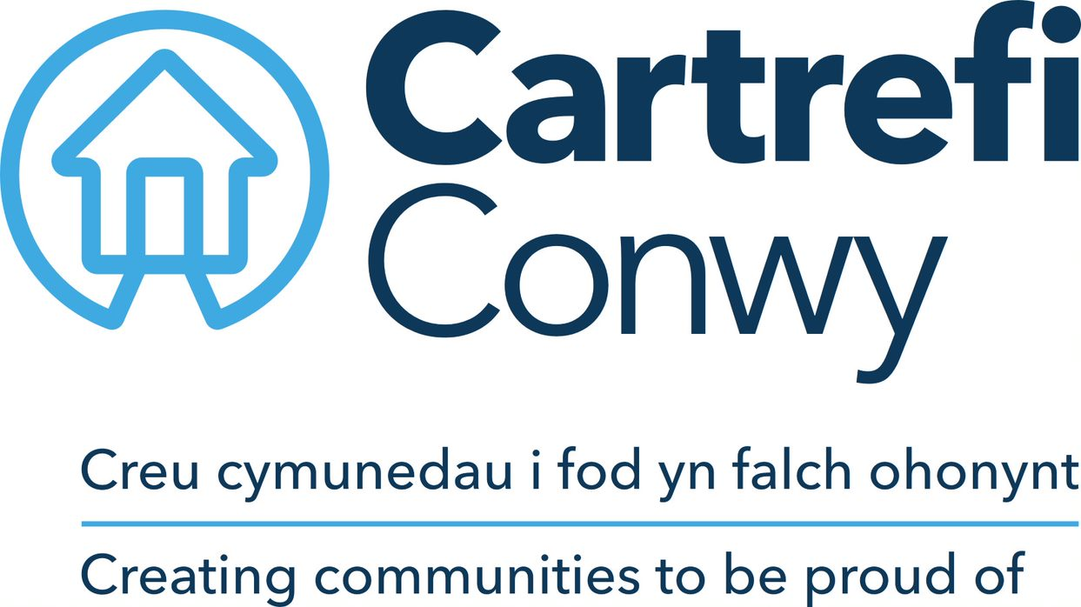 | Person Specification  MONEY SUPPORT ADVISOR

ACADEMIC / PROFESSIONAL QUALIFICATIONS | Essential / Desirable | How this will be assessed
5 GCSEs (or equivalent) passes at Grade C or above to include Maths and English | Essential | Application/ Certification
Completed Recognised Advisor training programme i.e. CAB, Law Centre or Welfare Rights training | Highly Desirable | Application & Certification
KNOWLEDGE & EXPERIENCE
Proven experience of providing professional Welfare Benefits advice and guidance | Essential | Application & Interview
Wide knowledge of the range of welfare benefits available and the qualification criteria | Essential | Application & Interview
Good knowledge of legal processes associated with Social Landlord and Tenant relationship | Essential | Application & Interview
Proven track record of maximising income by successfully claiming all eligible benefits for clients. | Essential | Application & Interview
Experience of writing appeal submissions and presenting cases at Tribunal | Essential | Application & Interview
SKILLS
Ability to effectively manage own case work and work load, including admin requirements and managing multiple cases. | Essential | Interview
Excellent interpersonal skills, to deal sensitively and professionally with tenants experiencing difficulties | Essential | Interview
Microsoft Office; Word, Excel, Outlook (Basic user level) | Essential | Ability Test
Full UK Driving Licence with the use of a vehicle for business purposes* | Essential | Application & Certification
Welsh Language Skills (Minimum Level 3 Speaking) | Highly Desirable | Application & Interview
Ability to negotiate effectively to achieve best outcomes for clients | Essential | Application & Interview
Core Cartrefi
Committed to Quality | Essential | Interview
Innovative | Essential | Interview
Doing the Right Thing | Essential | Interview

Cartrefi Conwy are committed to Equality and Diversity in our activities

* Where disability precludes, this will be reviewed with candidates at interview stage to ascertain if there are any reasonable adjustments that can be made to this requirement.

