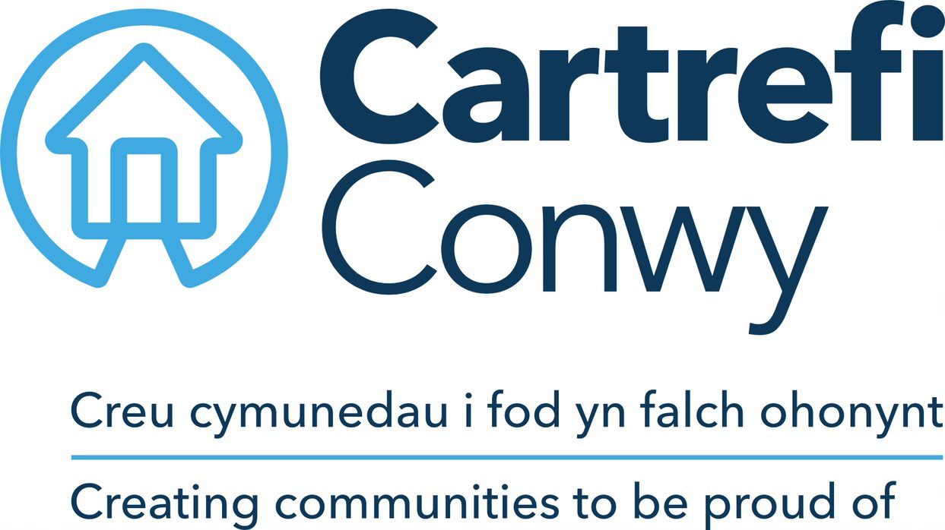 | Person Specification  Playworker

ACADEMIC / PROFESSIONAL QUALIFICATIONS | Essential / Desirable | How this will be assessed
A recognised playwork or childcare qualification | Desirable | Application / Interview
A first aid qualification | Desirable | Application / Interview
KNOWLEDGE & EXPERIENCE
Experience of community led projects | Desirable | Application / Interview
Experience of delivering a customer facing role and ability to work with community members | Essential | Application / Interview
Experience of working with children | Essential | Application / Interview
Experience of working in a small team of staff and volunteers | Desirable | Application / Interview
Basic understanding of health and safety practices | Desirable | Application / Interview
SKILLS
Ability to work with children face to face in a playful environment. | Essential | Application / Interview
Excellent organisational and time management skills in order to plan and deliver play sessions | Essential | Application / Interview
Excellent communication skills (both verbal and in writing) appropriate to a wide range of individuals and groups | Essential | Interview
Microsoft Office; Word, Excel (Basic user level) | Essential | Application / Interview
Ability to drive* | Essential | Application
Welsh Language Skills | Desirable | Application / Interview
CORE CARTREFI
 | Essential | Interview
  Committed to quality
  Innovative
  Doing the right thing

Cartrefi Conwy are committed to Equality and Diversity in our activities

* Where disability precludes, this will be reviewed with candidates at interview stage to ascertain if there are any reasonable adjustments that can be made to this requirement.

