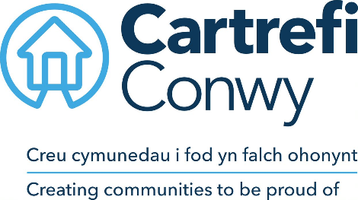
JOB DESCRIPTION

- JOB DETAILS
JOB TITLE | Receptionist
REPORTS TO | Customer Service Manager
DIRECT REPORTS | None
TEAM | Customer Services
LOCATION | Morfa Gele, Abergele
SALARY DETAILS | National Living Wage

- JOB DETAILS
To provide a great first point of contact service at our Head Office Reception. Be welcoming and professional whilst providing an efficient reception service and providing administrative support to the Customer Service team. Develop positive working relationships with customers, partners, stakeholders, and colleagues.
- JOB PURPOSE ‘The Challenge’
Welcoming visitors to the business
Taking incoming calls for all teams – approximately 100 per week
Handling incoming mail for distribution and preparing outbound mail for collection – approx. 150 items a week
Providing administration support for the Customer Service team, including outbound calls to confirm and arrange appointments – approx. 60 per week
- RESPONSIBILITIES ‘What you will do’
- Demonstrate a professional approach when providing a reception service to welcome visitors to the business.
- Provide a service or advice to visitors as appropriate: take messages or request support from colleagues when needed.
- Deal with customer and colleague’s queries via e-mail, phone and in person.
- Open, date and record incoming mail and documents including the cheques and postal orders. Distribute this mail to colleagues, electronically or in person as appropriate.
- Prepare and frank outgoing mail for the business.
- Receive, date and keep secure Tender documents, following the procedure to handover to the appropriate Officer.
- Maintain the professional image of the reception area including customer information, waiting area and plants/flowers
- Monitor the visitors signing in and out book and issue visitor passes, and door entry fobs as required.
- Monitor the electronic meeting room diaries, provide information to colleagues as needed to prepare the rooms and prepare welcome signage as needed.
- Support with the booking process for community centres
- Place orders with external suppliers.
- Take receipt of stationery orders and parcels and store them as appropriate
- Make outbound calls to customers to confirm and book appointments, for example for gas servicing appointments and ‘safe and well’ checks
- Receive keys from tenants and update the electronic records.
- Monitor and support use of the electronic hybrid mail system. This remote mailing system allows colleagues to send letter for mailing whilst working remotely.
- Attend meetings, (approx. 3 per month) to take notes and records actions.
- Other general administrative duties as required

- WORK CONTEXT (environment, type of equipment)
The post is predominantly office based with the requirement to travel locally on occasion for example to attend internal meetings or support tenant events.

To work with a degree of flexibility to ensure the Reception and administration needs of the business are met. This might mean working outside of normal office hours and at weekends when required and travelling to attend events as required.
 | - AGREEMENT
 | Job Holders’ Signature: |  | Date:
 | Line Managers’ Signature: |  | Date:

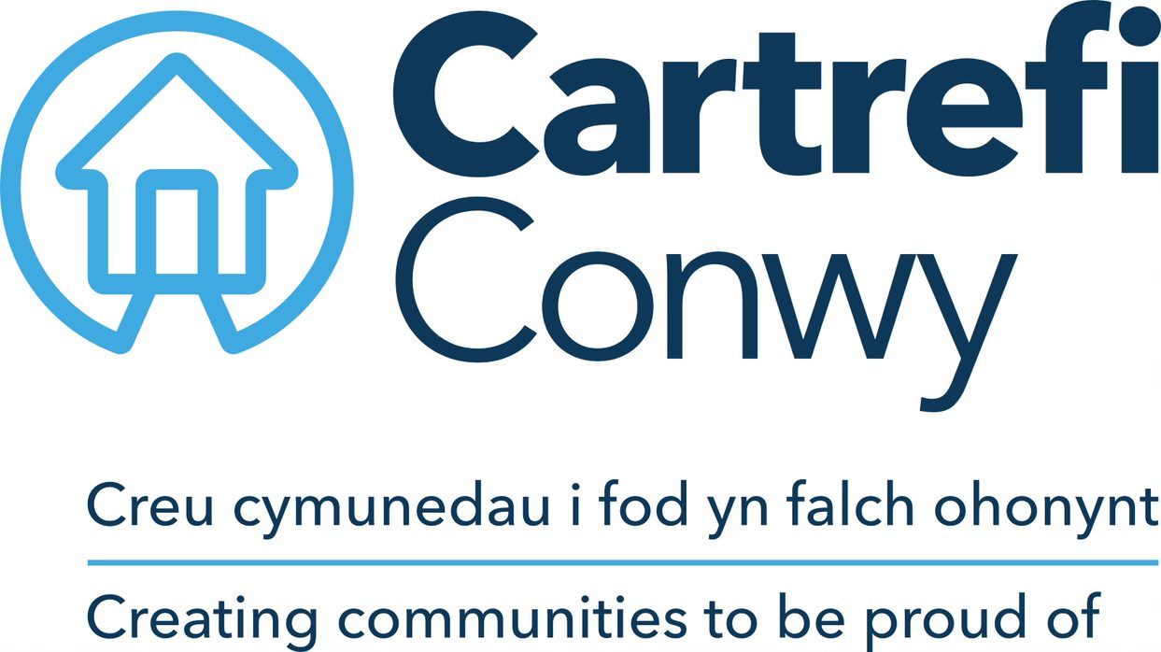 | Person Specification  Receptionist

ACADEMIC / PROFESSIONAL QUALIFICATIONS | Essential / Desirable | How this will be assessed
KNOWLEDGE & EXPERIENCE
Experience of providing a reception service | Desirable | Application / Interview
Knowledge and experience of office practices (telephony and administrative experience) | Essential | Application / Interview
Experience of working in a customer facing role | Essential | Application / Interview
Ability to remain focused in a busy environment and manage interruptions | Essential | Application / Interview
Ability to organise own workload and prioritise tasks as required | Essential | Application / Interview
Ability to use a range of ICT systems confidently | Highly Desirable | Application / Interview
SKILLS
Numeracy & Literacy Skills | Essential | Ability Test
Accuracy and attention to detail in data entry | Essential | Ability Test
Basic planning, prioritising and organising skills | Essential | Interview
Microsoft Office; Word, Excel, Outlook (Basic user level) | Essential | Ability Test
Welsh Language Skills | Highly Desirable | Application / Interview
CORE CARTREFI
 | Essential | Interview
  Committed to quality
  Innovative
  Doing the right thing

Cartrefi Conwy are committed to Equality and Diversity in our activities

